ServiceNow

**Knowledge Management**

**Quick Reference Card**



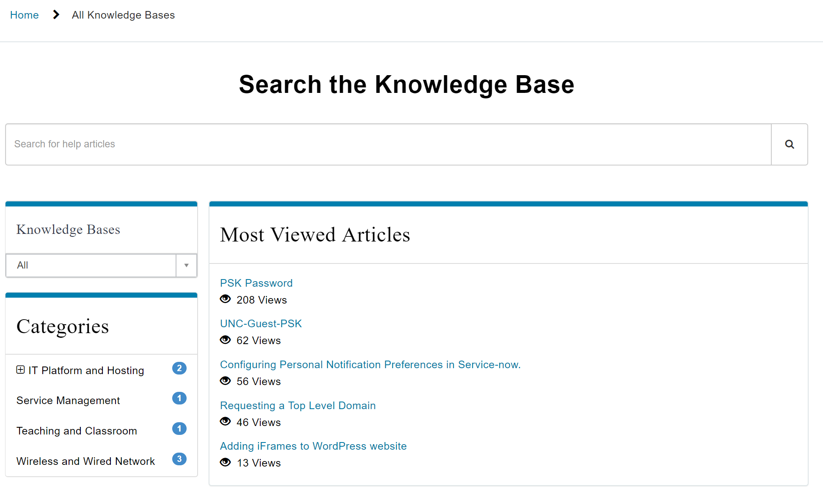

End User Access to Knowledge Management

Knowledge Management is the acquisition and use of resources to create an environment in which information is accessible to users. Knowledge Management helps users acquire, share, and use knowledge articles. Knowledge Management allows users to develop their own knowledge and apply this knowledge for the benefit of the organization.

The ServiceNow® Knowledge Management application enables the sharing of information in knowledge bases. These knowledge bases contain articles that provide users with information such as self-help, troubleshooting, and task resolution.

Knowledge Management supports processes for creating, categorizing, reviewing, and approving articles. Users can search and browse articles and provide feedback.

Search results include the articles and questions you are authorized to read. The search results count does not take into account any security rules set for the articles so the number of articles you could access may be lower than the count displayed in the search results page.

Documents that are attached to articles are also listed in the search results (for those articles to which you have access).

|  |  |
| --- | --- |
| **Knowledge Homepage** | **About Knowledge** |
| This application lets users search, view, and create knowledge. There are five main sections of the Homepage.    **<title>**  UNC-Chapel Hill end users access knowledge bases from the Service Catalog Portal using a link on the Portal Banner for the Knowledge Bases. In this view they can search for information across all knowledge bases they have access to and can provide feedback.  Knowledge articles are the instructional and informational content in knowledge bases. Knowledge can be created from the resolution of incidents or problems, imported from external sources, or authored in Knowledge Management. To create a new knowledge article:   1. Navigate to Self-Service > Knowledge. 2. Click Create an Article. 3. If configured, you have the option to select an article template. 4. Fill in the fields on the form. 5. Click Submit to create the article. (see Create a Knowledge Article section of this QRC)   Users can also initiate a new Incident from a knowledge article using the Create Incident Button. This creates a comment on the Incident referencing the knowledge article.  Knowledge Articles  Contains overall Knowledge Search and actionable items to execute activities for creating knowledge and posting questions.  Focused repositories of content. Knowledge bases are used as libraries of knowledge articles about a specific topic or business function.  Featured Content is a special designation for knowledge articles defined in knowledge bases. Featured Content is the distinctive content within Knowledge.  Most Useful content is a weighted list of Knowledge Articles based on end-user grading. Content with the highest user scores displays on this list.  Most Viewed content is a list of knowledge articles by usage. Usage is defined in the Knowledge Management Administration Properties and can range from 30/60/90 days out to several years.  **Banner**  **Knowledge Bases**  **Featured Content**  **Most Useful**  **Most Viewed** | **<title<title>**  **<title>** Knowledge Search  You can search for knowledge articles and social Q&A questions from the knowledge homepage using the search bar at the top of the page.  You can search All knowledge bases or, using the drop-down arrow, focus on a specific knowledge base. |

|  |
| --- |
| **Create a Knowledge Article** |
| Number Indexing Number assigned to the Knowledge Article (read only)  Knowledge Base (*) The knowledge base selected for this article.  **Note: An article can only be associated with one knowledge base.**    Category The category for this article. Select a Knowledge Base before you can select a category. Articles without a category appear on the knowledge homepage in the (empty) category.  Valid to The date this knowledge article expires. Articles do not appear in search results after the valid to date, or if the valid to date is empty.  Can Read List of users who are able to view this Knowledge Article  Cannot Read List of users who are restricted from viewing this Knowledge Article  Author User who developed the Knowledge Article content  Article title Customer visible Title of the Knowledge Article  Internal Notes Documentation for the Knowledge Article not visible when published.  SEO Keywords Search Engine Optimization keywords  Search Results Description Summary description displayed on the search results list  Version System generated version number for the Knowledge Article (read only)  Article Type The type of article, either HTML or wiki.  **Note: This field is only visible in the standard template.**    Workflow The publication state of the article, such as Draft or Published. When inserting a new article from an existing article, the state of the new article is reset to Draft. (read only)  Source Task The task this knowledge article was created in response to, if any. This field is set automatically when you create the knowledge article from a task record. (read only)  Attachment link Check box for downloading an attached file automatically when a user accesses the article, instead of opening the article view. Add one or more attachments to the article to use this option.  Display attachments Check box for displaying attachments to users viewing this knowledge article. Attachments appear below the article text. Add one or more attachments to the article to use this option.  Short description (*) The title of the article. This title appears when browsing and searching knowledge, and at the top of the article.  Text Content for the article. Use the HTML editor to create content. A preview of the content appears when browsing and searching knowledge        Note: You may attach multiple files, but most web browsers permit users to download only the first one. To ensure download of all the files, bundle them into an archive, such as with WinZip, and attach the archive.    Display attachments Check box for displaying attachments to users viewing this knowledge article. Attachments appear below the article text. Add one or more attachments to the article to use this option.  Short description The title of the article. This title appears when browsing and searching knowledge, and at the top of the article.  Text Content for the article. Use the HTML editor to create content. A preview of the content appears when browsing and searching knowledge.  Knowledge contributors can create and edit knowledge articles within a knowledge base to share information across the organization. Templates accelerate and standardize knowledge management content.  Some knowledge bases allow only certain users to contribute. For example, a member of the IT department can create knowledge articles in the IT knowledge base, such as desktop support information or articles describing company IT processes.  Complete the following fields to create a knowledge article.  Knowledge Articles can be imported from Word Documents. Use these steps to import a Word file.   1. Navigate to Knowledge -> Articles -> Import Articles 2. Select the Knowledge base to add the new article to.   You can select only knowledge bases you can contribute.   1. The Category List is dynamically updated with options to choose from based on the Knowledge Base. 2. Browse the local computer files to attach a Word Document to import or Drag and Drop the File onto the screen into the Import a Word File field. 3. Click the Import button.   Import Knowledge from Word |