ServiceNow
Incident Management

Quick Reference Card

ITIL Goal Statement
Incident Management Record Header
Incident Header Fields & Definitions  Unique identifier for the incident  Name of the person reporting the incident  Preferred communication method to contact the caller  Free text details of the contact method  The caller’s work location  The CMDB Business Service classification  The configuration item (CI) affected by this incident  Flag to open up the CI List to show all Classes of CI’s  Measure of the business criticality of the affected service  The extent to which resolution of the incident can bear delay  Sequence in which an incident needs to be resolved  Check box that recommends drafting a knowledge article from the incident  Brief description of the caller’s issue  Journal field containing internal documentation  Journal field containing comments visible to the customer  Indicates the current status of the incident  System-generated date and time the incident was opened  User name of logged in person creating the Incident  Workflow state of the incident  Primary categorization of the incident – used for making assignments  The department assigned to the caller’s user profile  The group assigned to work on this incident  The user within the group assigned to work on this incident  Restricts access of the incident to a sub-set of staff for working the incident  List of users who receive notifications and messages for all customer-visible documentation within the Incident  Number  * Caller  Preferred Contact Method  Preferred Contact Method Details  Location  Business Service  Configuration Item  Show All CI’s  Impact  Urgency  Priority  Knowledge  * Short Description  Work Notes  Additional Customer Comments  Activities  Opened  Opened by  State  Category  Department  * Assignment Group  Assigned to  Sensitive  Watch List | Goals of Incident Management  The goal of the incident management process is to restore normal service operation as quickly as possible and minimize the adverse impact of incidents on business operations, thus ensuring that the best possible levels of service quality and availability are maintained.
Details Tabs
Work Notes and Additional Comments to document work on the incident.

Information on related Problem and Change records

Documentation on how the incident is resolved. This can be used to create knowledge.

Notes

Related Records

Resolution Information
The Incident contains four tabs to let you work with this information in the incident record:
 | Related Links
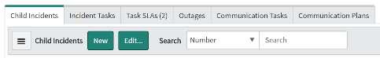
- Child Incidents
- Attachments
- Task SLAs
- Affected CIs
- Alerts
Related Links on the Incident Record are the one-stop-shop that let you do all incident management activities from the Incident Record. This section includes:
 | Additional Actions
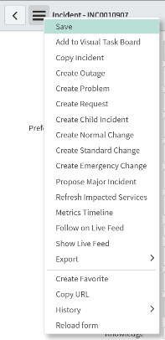
Additional Actions (on the banner) let you:
- Save the incident
- Add incidents to a Visual Task Board
- Copy the incident
- Create associated Problem Task Records
- Create associated Normal or Emergency Change Requests
- Show the Metrics Timeline
- Show/Follow on Live Feed

Users can open new incidents through the Service Catalog
- Start by going to the Service Catalog at help.unc.edu.
- On the Portal Homepage click the Something’s Broken icon to create a new incident.
- Choose your department
- Select the Urgency, which is the measure of Business Criticality.
- Enter a detailed description of the issue that you need help to resolve.

Once complete and submitted an Incident is created and will show as New for the ITS Service Desk to evaluate and process.

This way of creating incidents is best suited for end users needing help.

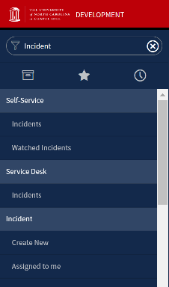
- Navigate to Incident > Create New or click New from the Incident list view.
- In the Incident Header, complete as much information as available. The Caller and Short Description fields are required fields.
- Click Submit to save and return to the previous screen or right click the Banner Frame and click Save to save and stay in the Incident.

Both saving method advance the workflow of the Incident and open the Details Tabs and Related Links section of the form.

Creating Incidents from the Portal

Create Incidents in ServiceNow

View & Edit Incidents on the Portal
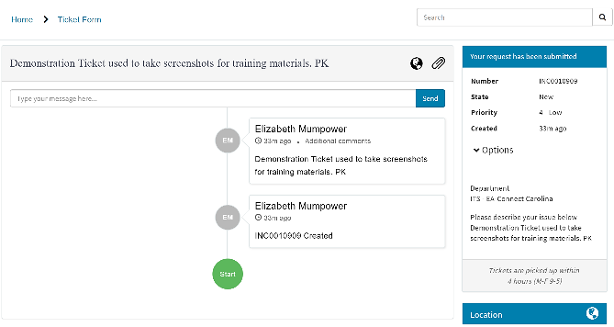
Users can monitor and update open incidents through the Service Catalog
- Under ‘My Requests’ on the Portal Homepage, locate the incident you would like to review and edit.
- Click the Incident Description to open a Portal View of the incident.
- Enter message details to update the Additional Comments (customer visible) notes on the incident.
- Users can also add attachments through the Attachments section.

When the Incident State passes New, the full record is available to work. Follow these guidelines when working the ticket:
- Use the Incident State field to indicate progress on the incident: In Progress, On-Hold, Resolved, Complete or Canceled.
- When an incident is created through the Service Portal, the details of the submission are in the Description field. As you work the incident you can update these details and fill in missing information.
- On the Notes Detail Tab enter Work Notes to log actions taken to resolve the incident. Post customer-visible notes in Additional Comments.
- Click the filter icon next to the Activities section in Notes to add or remove details from displaying on the screen.
- Associated Task Records such as problems and changes are documented automatically when associated to the Incident. When problems are resolved and changes implemented, the associated incidents are also updated.
- Monitor SLA’s to ensure the incident is resolved according to standards set by the organization.
- Enter Child Incidents to associate incident records. Associated records can share details and if needed promote the creation of Problem Records.
Working the Incident

Resolving the Incident
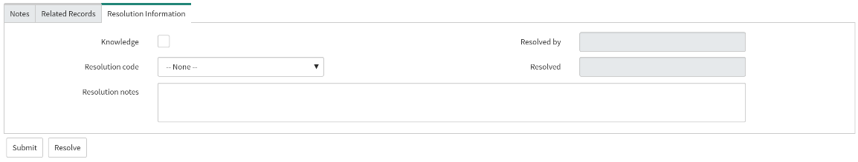
For More Information
When the underlying cause of the incident has been discovered and resolved you can close the incident:
- In the Incident Header change the State to Resolved. An error check will ensure all required fields are complete. This will start an automatic closer timer that when expired will automatically advance the Incident to Closed.
- On the Resolutions information Details, Select a Resolution Code
- Enter a detailed Resolution Note
- Click the Resolve button
ServiceNow facilitates communication between users and co-workers to collaboratively solve incidents and fulfill requests through Connect Chat.

In the Incident Record go to the Banner and click the Follow Buttons to be notified of new comments or work notes according to your notification settings.

Click the down arrow next to Follow to access the Connect Mini and Connect Full chat boxes. If accessed from the incident, conversations post to Work Notes or Additional Actions based on the option selected.
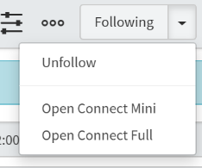
To request assistance and more information on how to use Incident Management, contact the Service Desk.

Collaborating on an Incident

- Chat Now
- Walk-in
- Call 919-962-HELP

